

**FACULTY OF ENGINEERING**

**COMPUTER ENGINEERING DEPARTMANT**

**FALL 2021**

**SOFTWARE ENGİNEERİNG**

Customized Visual Bookshelf from Gutenberg Project

14.12.2021

170316036 – Kardelen ÇETİN

170316044 – Muzaffer ÖZEN

170316006 – Ayseli Erem BATI

170316053 – Tuğrul Can MERCAN

200315006 – Ömer BENEK

Manisa Celal Bayar University Computer Engineering Department

CSE4123 Software Engineering Fall 2021

Project Documentation

Customized Visual Bookshelf from Gutenberg Project

**Table of Contents**

Table of Contents………………………………………………………………………………2

Introduction ……………………………………………………………………………………3

Proposed System ………………………………………………………………………………3

Overview ………………………………………………………………………………………3

User Reqiurements ………………………………………………………………….................3

System Requirements ………………………………………………………………………….4

System Stakeholders ……………………………………………………………………..........4

Functional Requirements ……………………………………………………………………...5

Non-Functional Requirements………………...……………………………………………..5,6

System Model …………………………………………………………………………………6

Scenarios ....................................…………………………………………………….6,7

Use Case Model ....................................……………………………………......7,8,9,10

Object Model ………………………………………………………………………....11

Dynamic Model ……………………………………………………………………......

User Interface Mock-ups ………………………………………………………………

**Introduction**

The name of our application is Libros. The main purpose of our application is to be able to search for and read books and collect selected books in a visual library for a specific user of the system. Each user should be able to see their own library when they log in and change the books in their own shelf by making new searches. The user can remove a book from the shelf when the book is finished. The user should be able to see the page in the book he/she has stopped reading the next time he/she logs into the system. We wanted to use the GitHub tool in our project, you can see our stages from the GitHub link of our project. GitHub tool has been the most suitable tool for us both in terms of manageability and in terms of our business life.

Our Project GitHub Link: https://github.com/kardelencetin/SoftwareEngProject

**Proposed System**

1. The feature that distinguishes the system we propose from other systems is that each user should see their own library when they log in and be able to change the books on their shelf by making new searches, or they can remove the book from the shelf when the book is finished.
2. In addition, another feature that distinguishes it from other systems is that the user can see the page on which he paused reading. In addition to the visualized library, the user is also shown a pop-up screen showing which book is paused on which page.
3. This application, which simulates the virtual library, can make many people gain the habit of reading books.
4. In addition, we take the burden of books off our shoulders, and we can easily access thousands of books or our virtual library that we have created by phone or via the web. In this way, we can easily access our library and read books at every moment of our lives.

**Overview**

The purpose of this system is to provide features such as reading and viewing a book. The user can see the page on which you are left in the book, create a library and remove a book from the shelf when the book is finished.

**User Reqiurements**

1. Each user must have their own account and be able to log in to the system with this account.
2. The application shall provide the ability to search and read books for the user.
3. The application shall show the user where the user has left in their boks.
4. The application shall the user to add the books he likes to his/her library.

**System Requirements**

1. Each user must have their own account and be able to log in to the system with this account.
   1. The information of the user's account should be able to be stored in the system.
   2. The system should be able to remember the user in all logins after the first login to the system.
   3. Each user must have an individual account in the system.
2. The application shall provide the ability to search and read books for the user.
   1. Books should be able to be searched by filtering in the system.
   2. The user should be able to access the books registered in the system.
   3. A list of the books that the user has read in the system should be able to be kept.
3. The application shall show the user where the user has left in their boks.
   1. The system should be able to show the user's last stay in the books.
   2. The system must refresh the updated information each time the user logs in.
   3. When the user logs out or closes the application, the system should still be able to show the page the user was left on.
4. The application shall the user to add the books he likes to his library.
   1. The system should be able to add the books that the user likes to her/his library.
   2. The system should be able to delete the books that the user does not want to be in her library.
   3. The system should be able to update the user's library and store the updated data.

**System Stakeholders**

* Users whose have an account in the system.
* Software Developers ​who are responsible for installing and updating the system.
* The company that provides the books data to the application.

**Functional Requirements**

* The user must be able to login to the system.
* The user must be able to register in the system.
* If the user forgets her/his password, she/he should be able to change her password.
* The user should be able to create a library on the system.
* The user should be able to view the books in the library.
* User should be able to delete books in library.
* The user should be able to see where she/he left off in her books.
* User should be able to search for books.
* The user should be able to add books to the library.
* The user should be able to search for another book while reading a book.

**Non-Functional Requirements**

**->Performance:**

**-**Users can access books all day long.

**->Usability:**

-Users should have access to all 60,000 books available in the app.

-Users can access the books in the system with the name of the author and the name of the book.

-When the user continues to read a book, he will be able to see which page he has left.

**->Functionalty:**

-The system should provide more than one functions and services to the user.

**->Reliability:**

-Only the user who created the account can access the account created by the user.

**->Supportability:**

-The application can support up to 10000 users.

-Users can only read the books in the application online.

**->Rapid Develeopment:**

-The system should be developed quickly.

**->Low-Coast:**

-While designing the system, the coast should be kept as low as possible.

**->Fault Tolerance:**

-Fault tolerance should be as low as possible.

**System Model**

**Scenarios**

**Scenario Name** ömerMeetsLibrasApplication

**Participating Actor Instances** Ömer, Muzo : Reader

**Flow of Events**

1. Omer loves reading books, but his family doesn't like to buy books from

the library because he is in the pandemic period.

2. That's why he's doing research on how to read a book. As a result of his

research, he sees the Libras application and installs it with joy.

3. In order to log in to the application, it is necessary to register and register

by email. After confirming the message sent to his mail, he can log in to the

system. Now he had access to the books.

4. He immediately searches if the Sapiens book he has wanted to read for a long time is there, and he immediately finds it.

5. Later, he learned that he could add this book to his library by liking it, and

immediately added a few more books.

6. He started reading Sapiens and really liked it. But suddenly his phone rang

and his friend Muzo invited him to work on his graduation project.

7. When Omer goes to Muzo, he talks about the application and downloads

it because Muzo loves to read books.

8. Omer, who left the book halfway, realized that he had forgotten the page he

left off. He opened the application in a hurry, but the application was showing

where he left off and Omer was very happy.

9. Now Omer reads his books hygienically and does not forget the place

where he stayed.

**Scenario Name:** rachelSearchesForBook

**Participating Actor Instances** Rachel: Reader

**Flow of Events**

1. Rachel is majoring in English Language and Literature and needs to be able to purchase a book to research her teacher's assignment.
2. She logs into the Libros app she's using and sees if she can find the book she's looking for there.
3. This book is War and Peace by Fyodor Dostoyevsky. Since Rachel can't remember the name of the book, she wants to search for the author's name.
4. When Rachel writes the author's name, she thinks of which book to read when she sees the books that come before her.
5. She adds this book to the library she created for her account in the application so that she can access this book frequently.
6. She then finishes reading this book and removes it from her library.

**Use Case Model**

**Use Case Name:** SearchBooks

**Participating Actors:** Initiated by Reader

**Flow of Events:**

1. The reader typed the author of the book she/he needed in the search bar.

2. The system brought the author's books in front of the user.

**Entry Condition:** The reader must want to search for a book.

**Exit Condition:** The reader should be able to find the book.

**Quality Requirements:** The reader can search for 60,000 books.

**Exceptions:**1. The reader typed the author of the book she/he needed in the search bar.[bookNotFound]

**Use Case Name:** RemoveBooks

**Participating Actors:** Initiated by Reader

**Flow of Events:**

1. The reader deletes the book she/he no longer needs from her/his library.

2. The system removes the book from the library.

3. The reader saves the library and closes the application.

4. The system saves the history information of the reader.

**Entry Condition:** The reader must want to delete a book.

**Exit Condition:** The reader saves and closes the application.

**Quality Requirements:** When the reader enters her library, she should not see the deleted book.

**Use Case Name:** AddBookToTheShell

**Participating Actors:** User

**Flow of Events:**

1.The user types the name of the book she wants to search or the name of the author of the book in the search bar.

2.The system presents the book with that name or the books belonging to that author to the user in line with the information entered by the user.

3.As a result of the information entered, the user likes the book that she will choose from the books that come before her by pressing the like button.

4.The system adds the book that the user likes to the library in the user's account.

**Entry Condition:** User must search for a book or author name.

**Exit Condition:** The book that the user likes should be added to the user's library.

**Quality Requirements:** When the user searches for an author's name, she should be able to see all the books belonging to that author.

**Use Case Name:** RegisterToLibros

**Participating Actors:** User

**Flow of Events:**

1. After the user downloads the application, she enters the name , password and e-mail information to be registered.

2. The system sends a confirmation message to the e-mail address entered by the user.

3- The user approves the e-mail sent to the e-mail address.

4- When the system e-mail address is approved, it saves the user's account to the application in line with the information entered by the user.

**Entry Condition:** To register, the user must enter her e-mail address and other necessary information and confirm her e-mail address.

**Exit Condition:** The user must register in the system with the username and e-mail address she has written.

**Quality Requirements:** If the user does not receive the confirmation mail while trying to register, she should be able to request the confirmation mail again.

**Use Case Name:** LoginToLibros

**Participating Actors: User**

**Flow of Events:**

1. The user enters the user name and password used when registering to the system to log in.

2. The system directs the user to the account according to the information entered by the user.

**Entry Condition:** To login, the user must enter the correct username and password.

**Exit Condition:** The user should be able to see their own account and their own library.

**Quality Requirements:** If the user has forgotten her password while logging in, she should be able to receive a password renewal e-mail.

**Use Case Diagram**

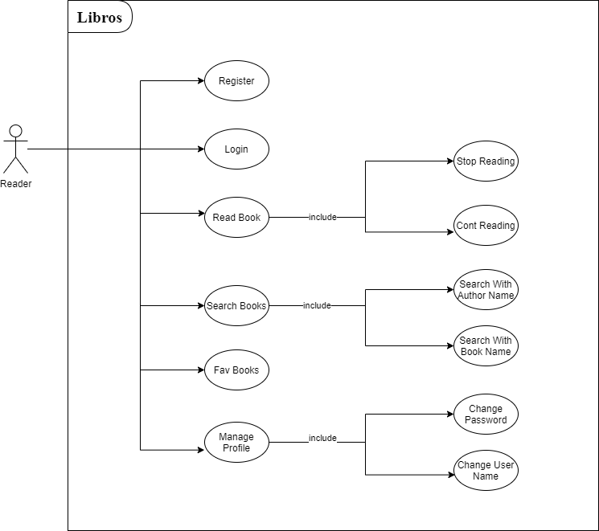

**Object Model**